**HOW TO CONVERT YOUR MICROVU POINT DATA TO SPATIAL ANALYZER.**

Last updated by Evan Bray on 8/26/2025

**PURPOSE:**

Converting exported MicroVu point data into a format that can be imported to Spatial Analyzer is a tedious process that requires a lot of copy/pasting in Excel. To this, I wrote a Python script called *InSpec_to_SA_converter.py* that simplifies the process. It works by taking a .csv file of point data that is exported by InSpec and rearranging the contents to a format that can be easily imported to Spatial Analyzer.

**REQUIREMENTS:**

* A basic knowledge of how to use the MicroVu is assumed (features, tools, “more inputs”, etc.)
* A flash drive for transporting files off the MicroVu PC.
* A PC with a working Python 3 installation and Spatial Analyzer. The MicroVu PC does not have these.

**REQUIRED READING FOR NEW USERS:**

Do NOT close InSpec until you’ve confirmed that the data has been properly imported to Spatial Analyzer. Point data does not get saved in the .iwp file, so if you close the file and reopen it, you will lose the point data that comprise your features.

**Example:** You use the MicroVu to measure the diameter of a pinhole. The circle displayed in InSpec is the result of fitting to the N points that were generated during the measurement (typically, N is large). The only data saved about that circle to the InSpec .iwp file is the (x,y,z) center, (i,j,k) pointing, and diameter. It did not save the information about the N (x,y,z) points used to create that circle. So, if you close your InSpec file and open it back up, you’re out of luck and have to start over ☹.

1. Within InSpec, toggle off “more inputs” if you have it selected, and highlight all the features in the feature tree by using CTR+A.
2. Navigate to Features->Exports through the top menu bar in InSpec.
3. For each item in the “Feature Type” drop-down box, make sure that the following boxes are checked:
   1. 3D MCS Points
   2. Export Labels
   3. 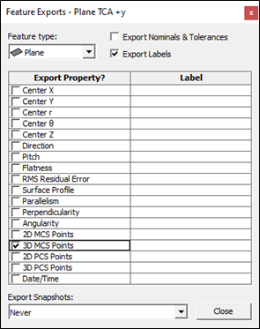
4. Close the Feature Exports window.
5. Navigate to File->Export.
6. In the resulting pop-up, select your filename and save location
   1. **Note:** Make sure to export the data as a .csv file, not .txt
7. Set delimiters to the values shown below. Not selecting these values will cause the SA conversion script to fail later. Save this to a flash drive and move it over to your own PC. **DO NOT CLOSE INSPEC YET.**
   1. 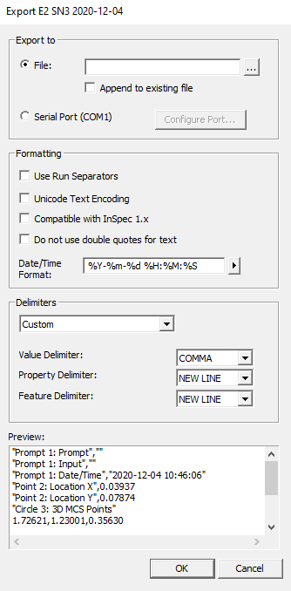
8. Close the Export window.
9. Run the *InSpec_to_SA_converter.py* Python script. A dialog box will appear asking you to select the file you wish you process. The output file will be placed in the same directory that the input file was located in.
   1. The MicroVu computer does not have a Python installation on it. You will need to copy the exported file to your own machine and run the script there.
   2. Text

      Description automatically generated
10. In Spatial Analyzer, navigate to File->Import->ASCII: Predefined Formats. Select the processed .csv file.
11. In the “ASCII Import” menu, ensure that the correct units are selected, and that the imported data format is set to “GroupName PointName X Y Z”.
    1. 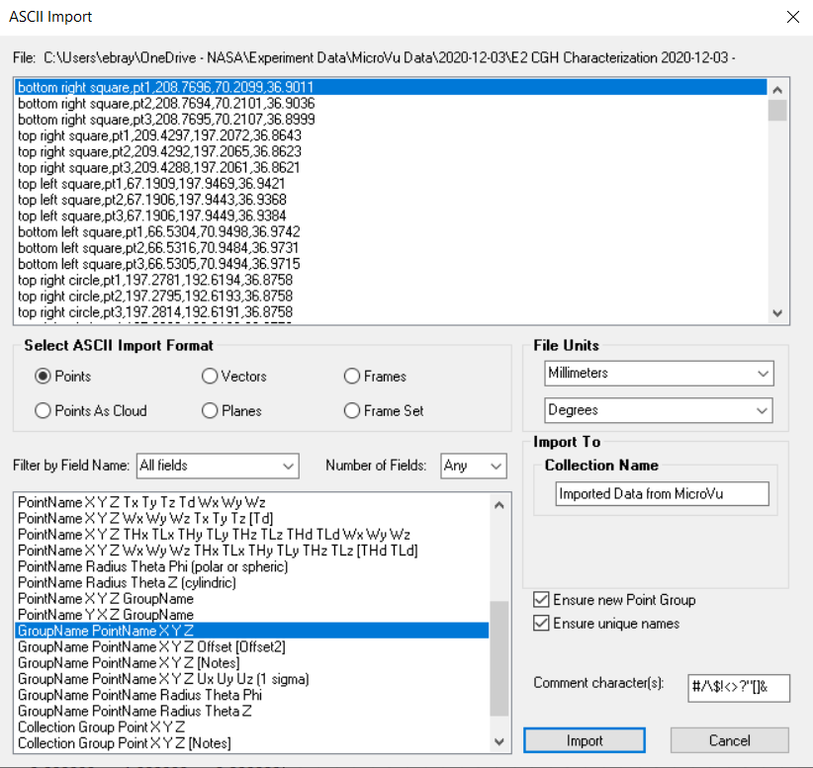
12. The imported points will be organized in groups according to the name you gave to the feature in InSpec.
    1. 